

Course Name: CSE 435  
Section: 02  
Faculty Initial: HUZ  
Project Name: 4- Bit Logic Unit (LU) – OR & INVERT  
Group Number: 9  
Group Members’ Name and ID:

|  |  |
| --- | --- |
| Name | ID |
| Arpan Biswas | 1430039042 |
| Swagata Mazumder | 1421204042 |
| Abrar ahnaf abid | 1411411042 |
| Lamia Farzana | 1210886045 |

**Not**

# 

# **NAND2**

# 

**AND2**

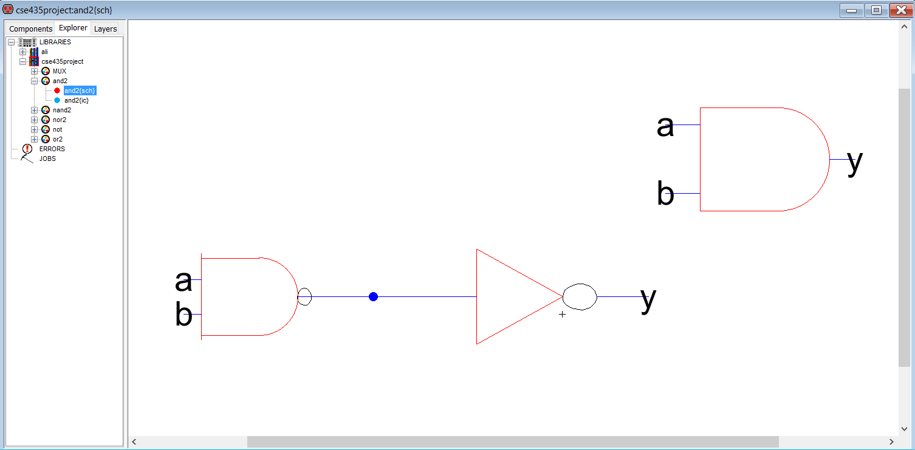

**NOR2**

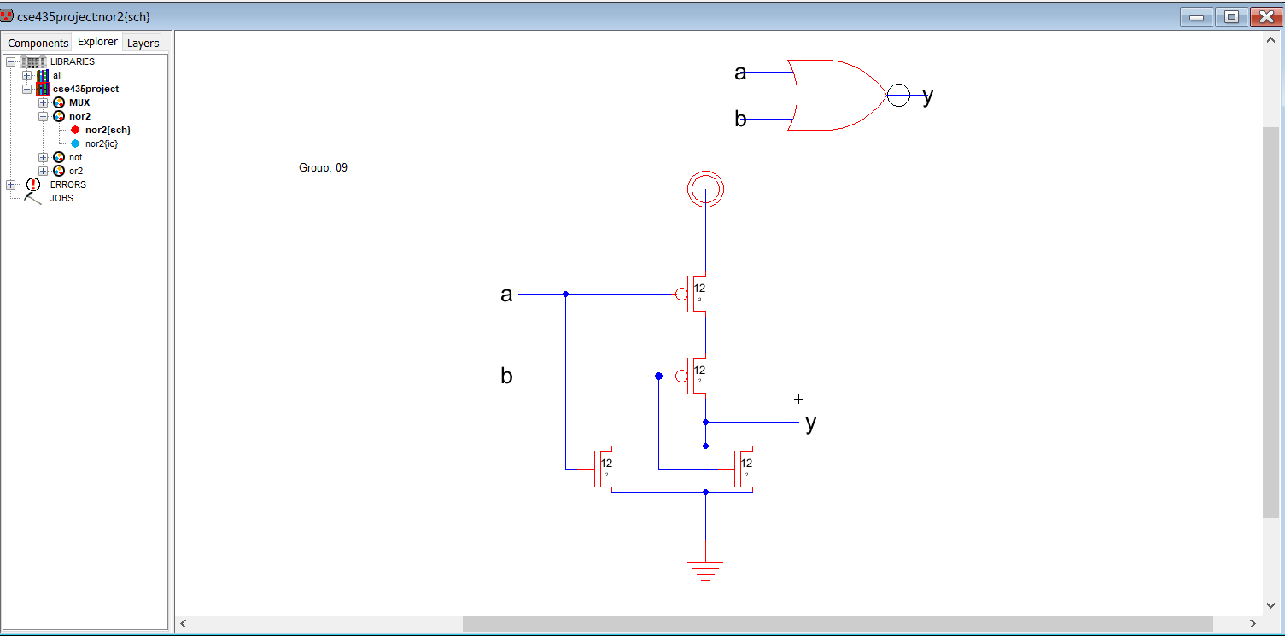

**OR2**

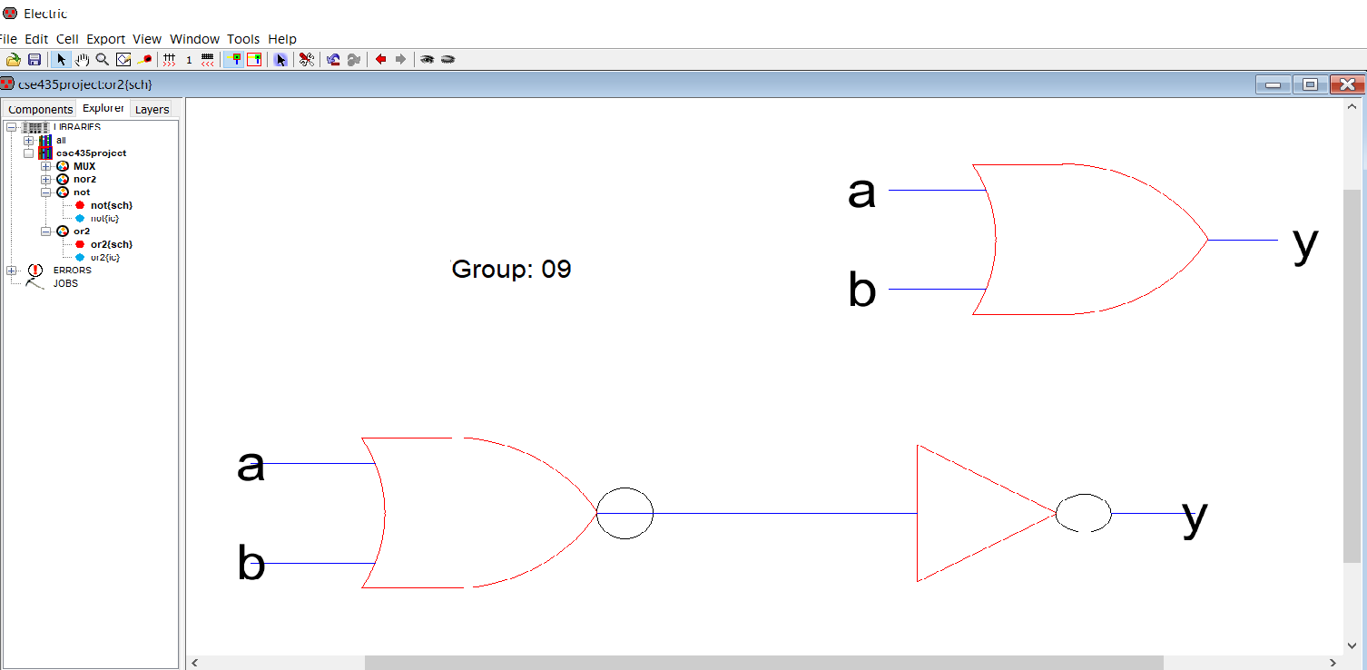

**MUX**

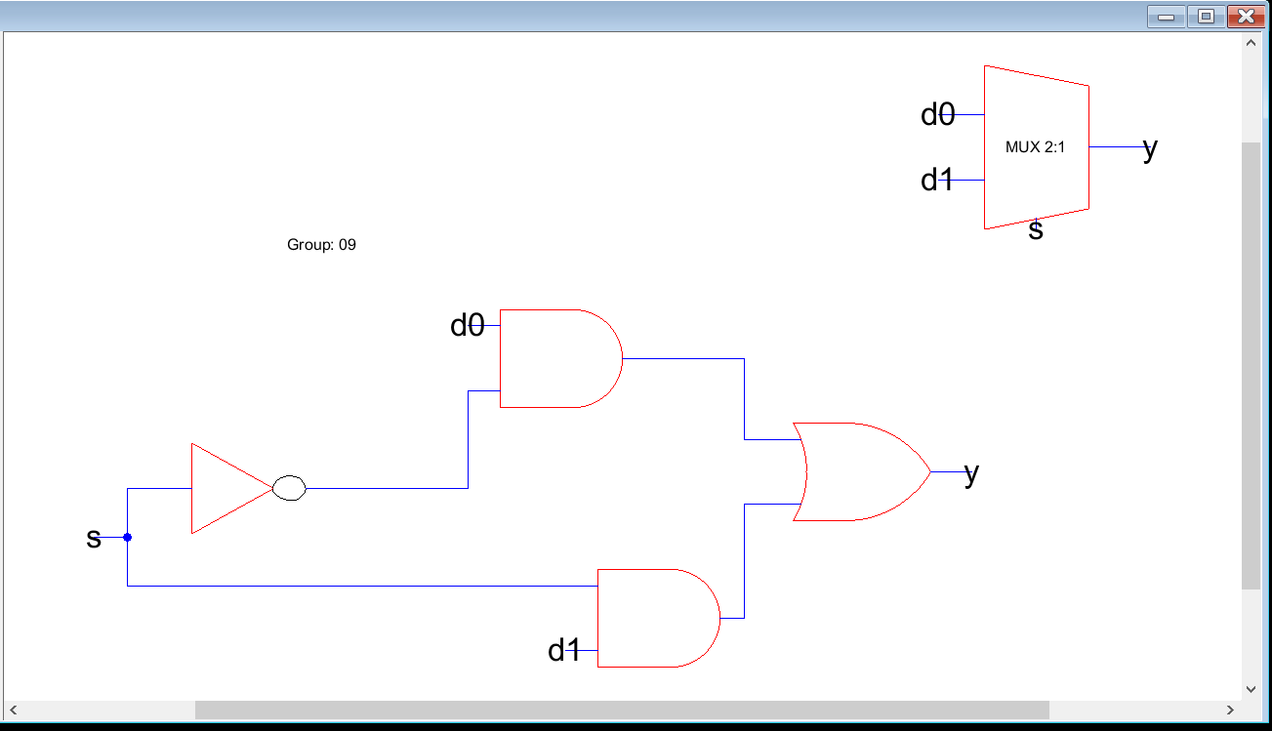

**Not simulation**

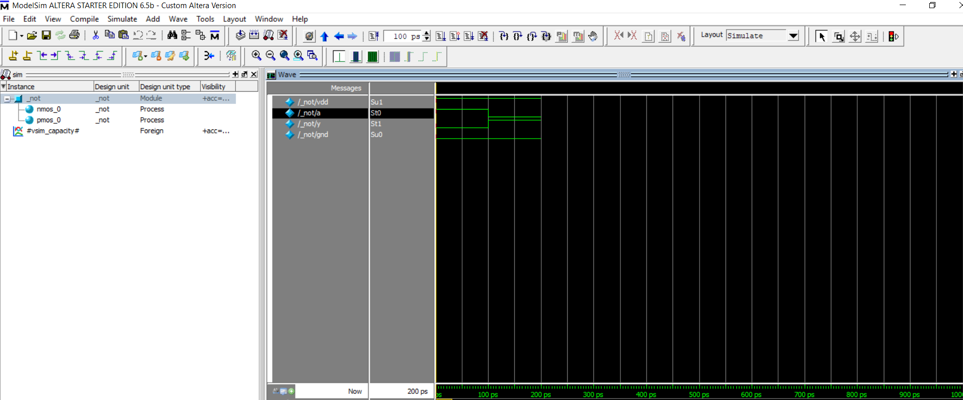

**Nor Simulation**

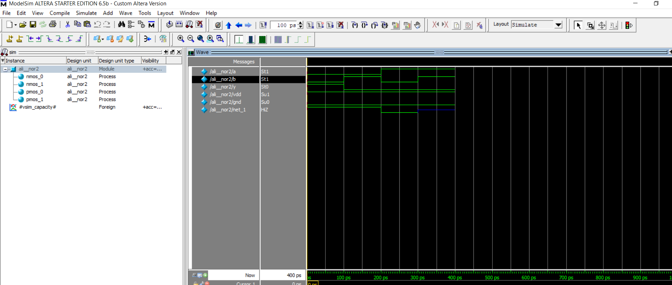

**Or Simulation**

